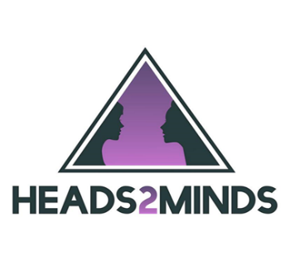

Heads2minds has been created in order to raise mental health awareness, educate, mentor and offer continued support to all people. Its’ aim is to reduce the stigma that is still very much attached to mental health disorders and especially due to the increase during lockdown and over the last year. Heads2minds offer all types of Mental Health and Well-being Training, including Mental Health First aid for both Adult and Youth. The charity is now branching out into schools and offers mentoring for children, animal therapy, colour therapy and art therapy to help children with their emotions and talking out about how they feel and their behaviours. The goal of the organisation is to make a difference in this world and create a world full of hope and positive minds. The charity is run by Liz Rotherham who is a local Essex girl empowering all people to be their authentic self.

Improved health and wellbeing for those with mental health conditions is one of the main drivers for the organisation. Heads2Minds aims to provide services that better support the physical, psychological and emotional needs of those with mental health conditions and for those supporting someone with a diagnosis.

